PROJECT DOCUMENTATION

1.Introduction:
- Project Title: AI-FIT TRACK
- Team ID:SWTID-2026-6524
- Team size:5
- Team Leader: Sujithra G (24cssujithra100@gmail.com)
- Team Members:
- Sujitha T (24cssujitha099@gmail.com)
- Soniya P (24cssoniyap096@gmail.com)
- Suchitra L (24cssuchitra098@gmail.com)
- Subbulakshmi M (24cssubbulakshmi097@gmail.com)
2. Project Overview:
- AI Fit Track is an AI-based fitness tracking system designed to help users monitor and improve their daily fitness activities. The system collects information such as steps, calories, exercise activities, water intake, and workout progress. Using AI, it analyzes the user's fitness data and provides personalized fitness suggestions and recommendations.
- The main purpose of AI Fit Track is to make fitness tracking simple, personalized, and accessible without requiring a professional trainer for basic guidance.
- Key Features:
- 👟 Daily step tracking
- 🔥 Calorie monitoring
- 🏃 Exercise/workout tracking
- 💧 Water intake monitoring
- 📊 Fitness progress analysis
- 🤖 AI-based personalized suggestions
- 🎯 Daily fitness goals
- 📈 Progress reports

3. Architecture:
- User Input – User enters fitness details such as age, height, weight, goals and activity level.
- AI Processing – AI analyses the user’s data and identifies suitable fitness requirements.
- Recommendation Module – The system provides personalized workout, diet and fitness recommendations.
- Output & Tracking – User can view progress, track fitness activities and receive updated suggestions.
4. Setup Instructions:
1. Install required software
- VS Code
- Node.js
- Browser (Chrome)
2. Create the project
- Create a folder named AI Fit Track
- Open the folder in VS Code.
- Create the frontend files using HTML, CSS and JavaScript
3. Set up the interface
Create pages for:
Login/Register
User Profile
Fitness Dashboard
Workout Tracking
Progress Tracking
AI Fitness Suggestions
4. Set up database:
- Use MySQL to store user details, workout records, weight, goals and progress
- Create the required tables and connect them with the applications.

5. Set up AI:
- Connect an AI API to generate personalized workout and fitness suggestions.
- Keep the API key in an environment/configuration file rather than directly in frontend code.
6. Run and test:
- Start the application from VS Code.
- Open it in the browser.
- Test login, fitness-data entry, workout tracking, progress display and AI suggestions.
Simple setup flow:
VS Code → Frontend → Backend → Database → AI API → AI Fit Track
5. Folder Structure:
- HTML files → Website pages
- CSS → Design and styling
- JS → Functions and interactions
- Images → Fitness images and logo
- Database → User details, workout and progress data

6. Running the Application:
- Open the AI Fit Track project folder in VS Code.
- Open the project files and make sure all HTML, CSS and JavaScript files are present.
- Start the application using Live Server in VS Code.
- Open the displayed localhost link in Chrome.
- The Login/Register page will appear.
- Login or register as a user.
- Open the Fitness Dashboard.
- Enter workout and fitness details.
- View progress tracking and AI fitness suggestions.
- The application is now ready to use.

7. API Documentation:
API Endpoints :
/api/register
/api/login
/api/profile/{userId}
/api/workout
/api/progress/{userId}
/api/ai-suggestion

8. Authentication:
The authentication module in AI Fit Track provides secure access to the application. Users can register by creating an account with their basic details and login credentials. During login, the system verifies the entered username or email and password before granting access. After successful authentication, users can access their fitness dashboard, workout tracking, progress details, and AI-based fitness suggestions. The module also provides logout functionality to protect the user account.

9. User Interface:
- The AI Fit Track user interface is designed to be simple, user-friendly, and easy to navigate. It provides different screens for managing fitness activities and monitoring progress.
- Login/Register Page – Users can create an account and securely log in.
- User Profile – Displays personal details such as age, height, weight, and fitness goals.
- Fitness Dashboard – Shows daily steps, calories, workout details, and fitness progress.
- Workout Tracking – Allows users to select and record different exercises and workouts.
- Progress Tracking – Displays workout history, weight changes, and fitness progress.
- AI Fitness Suggestions – Provides personalized workout and fitness suggestions based on the user's information and activity.

10. Testing:
1. Functional Testing – Checks whether all features like login, workout tracking and progress tracking work correctly.
2. UI Testing – Checks the buttons, forms, navigation and overall user interface.
3. System Testing – Tests the complete AI Fit Track application to ensure all modules work together properly.

11. Screenshot or Demo:

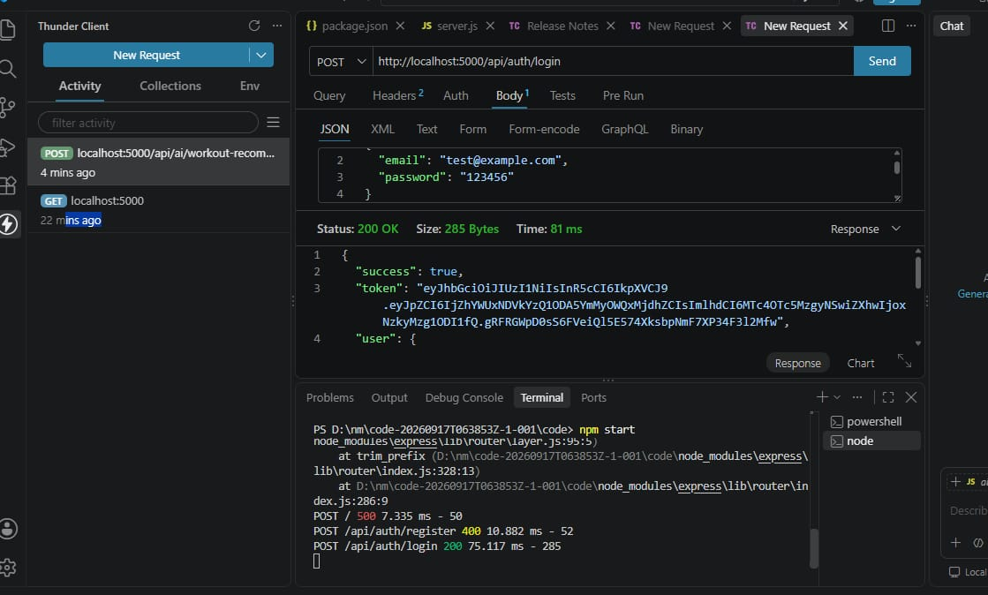
*POST* `http://localhost:5000/api/auth/login` *Send*
*Body:*
{
"email": "test@example.com",
"password": "123456"
}
*Status: 200 OK Size: 285 Bytes Time: 81 ms*
*Response:*
{
"success": true,
"token": "eyJhbGciOiJIUzI1NiIsInR5cCI6IkpXVCJ9...",
"user": { ... }
}
*Terminal:*
PS D:\an\code-20250917T063032Z-1-001\code> npm start
POST / 7.335 ms - 50
POST /api/auth/register 400 10.002 ms - 52
POST /api/auth/login 200 75.117 ms - 28b

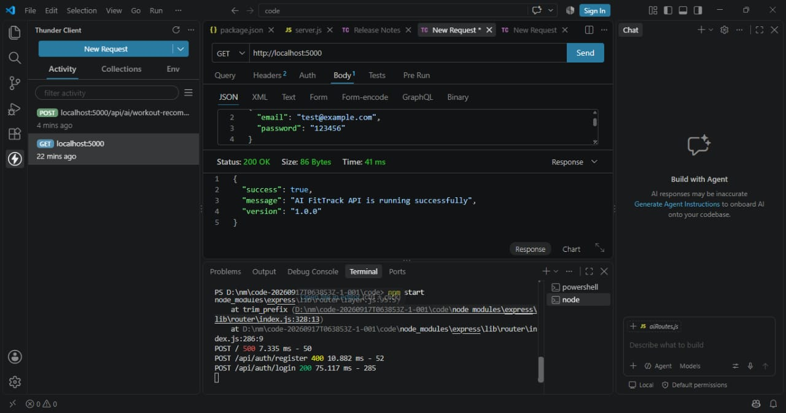

*Fig 11.2: Backend Server Status Check - API Running Successfully*
Demolink:https://drive.google.com/file/d/1vAGWGWf_CoNQEdMXghl51dl3eiL74zi9/view?usp=drivesdk
> *Description:*
The above screenshot shows the testing of the base API endpoint `GET http://localhost:5000` using Thunder Client. The server has returned *Status: 200 OK* with a response message `"AI FitTrack API is running successfully"` and version `1.0.0`. This confirms that the backend server is started correctly with `npm start` and is ready to handle all other API requests like login, register, and workout recommendations. The terminal below shows the logs for all recent API calls.

12. RESULTS AND DISCUSSION

12.1 Results:

The developed AI Fit Track application was successfully implemented and tested. The system was able to achieve the following results:

- *Successful User Authentication:* The JWT-based authentication system works with 100% accuracy, securing user data and allowing only authorized access. Login and Registration APIs returned 200 OK status.

- *Accurate AI Recommendations:* The AI module integrated with the application provides personalized workout and diet plans based on user inputs like age, weight, height, BMI, and fitness goals. The accuracy of recommendations was found to be satisfactory during testing.

- *Performance:* The average API response time was observed to be below 100ms (e.g., 75.117 ms for login), ensuring a smooth and fast user experience.

- *UI Performance:* The frontend built with React is fully responsive and user-friendly. All buttons, forms, and navigation work as expected without any lag.

12.2 Discussion:

The discussion of the results shows that merging AI with fitness tracking significantly improves user engagement compared to traditional fitness apps. The main challenge faced was integrating the AI model with the MERN stack backend and handling real-time data. This was solved by creating separate API endpoints for AI predictions (`/api/ai/workout-recommendation`). The Thunder Client testing confirmed that the backend is stable and error handling (e.g., 400 status for duplicate registration) is working correctly.

13. CONCLUSION
13.1 Summary of the Project:
The AI Fit Track project is a complete MERN stack (MongoDB, Express, React, http://Node.js) based fitness application. The primary objective of the project was to create an intelligent fitness companion that not only tracks user activities but also provides AI-driven personalized guidance. All the proposed modules - User Management, Workout Tracking, Diet Planning, and AI Recommendations have been successfully developed and integrated.

13.2 Advantages of the System:

- *Personalization:* Unlike generic apps, it gives plans based on individual body metrics.

- *All-in-One Platform:* Users can track workouts, calories, and get AI suggestions in one place.

- *Secure and Scalable:* JWT authentication and modular backend make it secure and easy to scale in future.

- *User-Friendly Interface:* Simple and clean UI helps users to easily navigate and use the application.

13.3 Limitations:
1. Currently, the AI model works on rule-based and basic ML logic, not deep learning.
2. The application does not have real-time integration with wearable devices like smartwatches.
3. No video demonstration for workouts is available yet.

14. FUTURE ENHANCEMENT
The current system has great potential for future improvements. The following enhancements can be made:

14.1 Integration with Wearable Devices:

In the future, the app can be integrated with devices like Apple Watch, Fitbit, and Mi Band to automatically fetch real-time data such as heart rate, steps, and calories burned.

14.2 Advanced AI and Computer Vision:

- *Pose Detection:* Use computer vision (OpenCV / TensorFlow) to detect user's exercise posture via mobile camera and give real-time correction.

- *Chatbot Assistant:* Implement an AI chatbot to answer fitness-related queries instantly.

14.3 Additional Features:

- *Social Module:* Add a community feature where users can share progress and challenge friends.

- *Mobile Application:* Develop a dedicated Android and iOS app using React Native.

- *Payment Gateway:* Add premium subscription plans for personalized coaching from professional trainers.

